Title
A CORE SPICE Asset
Table of Contents
1 Purpose 2
1.1 Text 2
1.1.1 Text 2
2 Scope 2
3 Chapter…. 2
4 References 3

Purpose

Text

Text

Text
- Bullet point
- Bullet point
- Bullet point
- Bullet point
Text..

Scope
The scope of this approach is <Scope of Approach>

Chapter….
This is a placeholder.
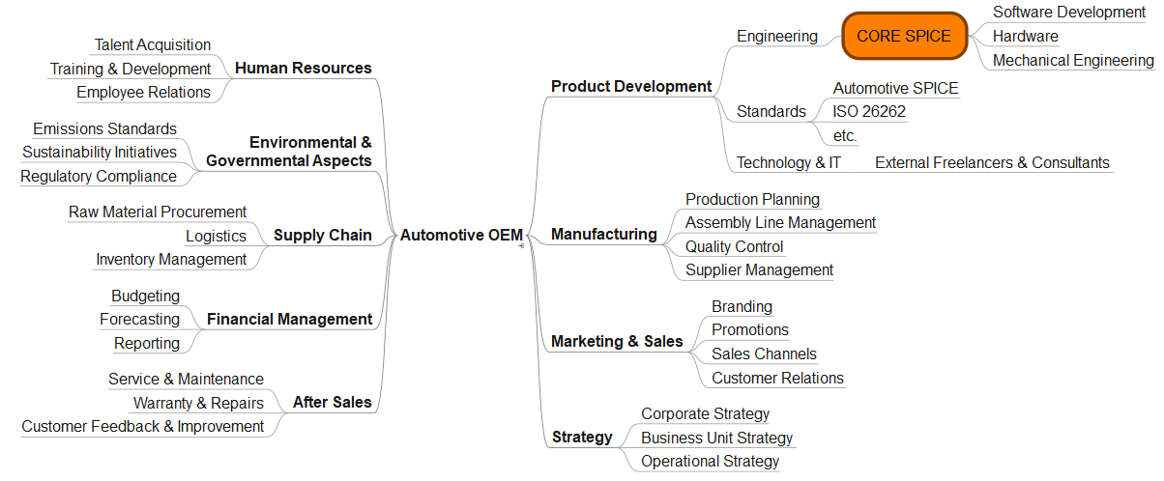
Figure 1 Example
The ability to react to changes in the automotive industry – or, even better, to act proactively – determines the success or failure of a new vehicle platform. Gone are the days when you could take four to five years—the latest competition – whether Tesla or Chinese manufacturers such as BYD—is setting an enormous pace. At the same time, there is a weak correlation between conventional development process quality and product quality in the traditional car design business. In our industry, complex processes are often designed and introduced throughout development teams, and there is a perception that meticulously detailed development processes should be the source of creativity and product quality. Traditional models such as ASPICE are frequently developed as extensions of the ASPICE specification, leading to complex and bloated development processes.
Test | Test | Test
Test | Test
Tes | test
Tab. 3.1 Example
However, our practical experience has shown that we cannot completely abandon the process concept and the entire Automotive SPICE principle in favor of purely agile methods. That would be impossible in a safety-relevant industry such as automotive engineering. The idea introduced in this book, CORE SPICE, represents our approach, which leverages decades of process improvement knowledge and experience while avoiding the complexity of ASPICE. This approach concentrates on essential process quality elements, the engineering mindset, and effective project management. CORE SPICE emphasizes quality and a culture of professional collaboration among all involved system and software development teams. It also emphasizes customer involvement at an early stage of a development project.

References
References here…

